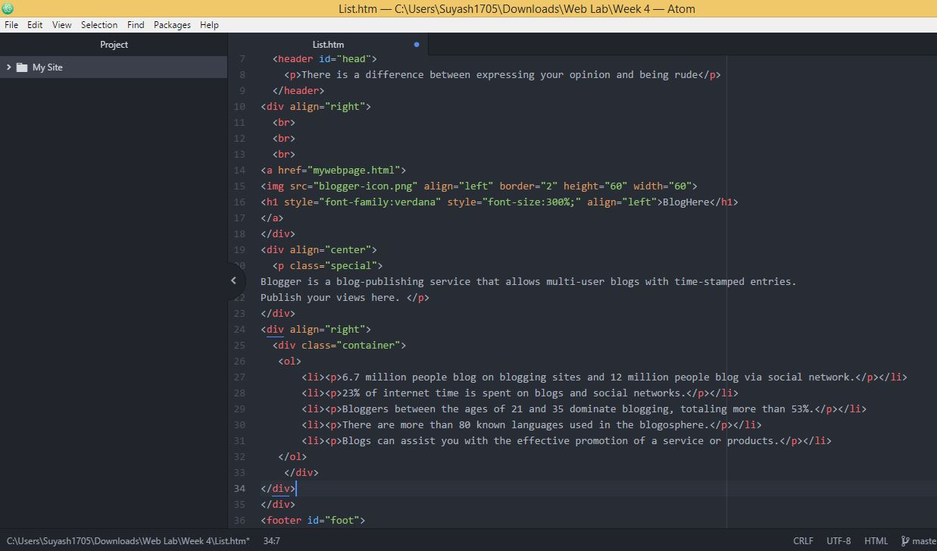

**Source Code**

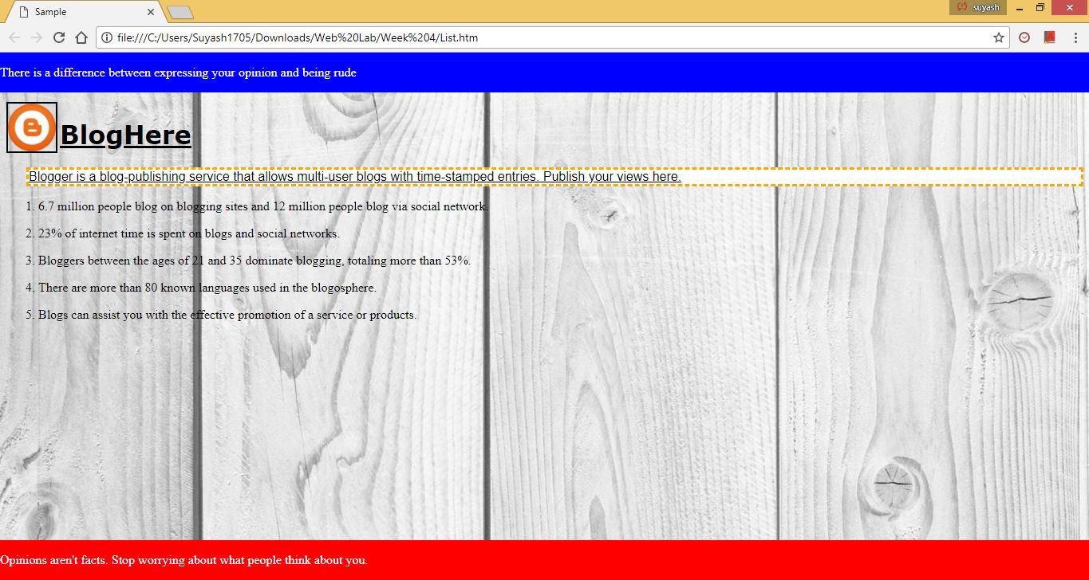

**Web View**

HTML offers web authors three ways for specifying lists of information. All lists must contain one or more list elements. Lists may contain −

* **<ul>** − An unordered list. This will list items using plain bullets.
* **<ol>** − An ordered list. This will use different schemes of numbers to list your items.
* **<dl>** − A definition list. This arranges your items in the same way as they are arranged in a dictionary.

**HTML Unordered Lists:**

An unordered list is a collection of related items that have no special order or sequence. This list is created by using HTML **<ul>** tag. Each item in the list is marked with a bullet.

## HTML Ordered Lists:

If you are required to put your items in a numbered list instead of bulleted, then HTML ordered list will be used. This list is created by using **<ol>** tag. The numbering starts at one and is incremented by one for each successive ordered list element tagged with <li>.

**HTML Definition Lists:**

HTML and XHTML supports a list style which is called definition lists where entries are listed like in a dictionary or encyclopedia. The definition list is the ideal way to present a glossary, list of terms, or other name/value list.

Definition List makes use of following three tags.

* **<dl>** − Defines the start of the list
* **<dt>** − A term
* **<dd>** − Term definition
* **</dl>** − Defines the end of the list